Install Eclipse Oxygen

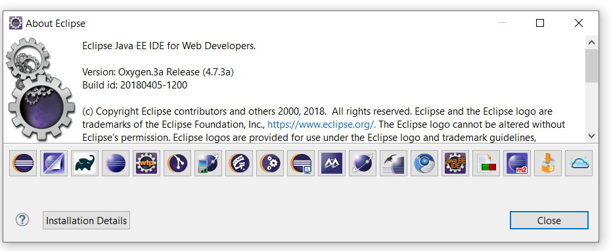

Take mysetup and do it